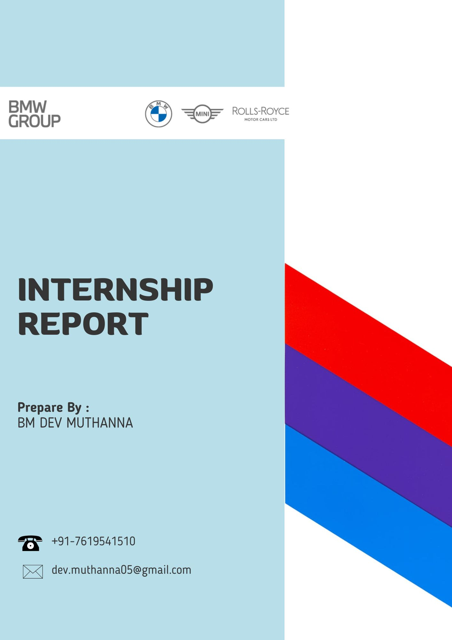
+91 99525 82911
mail2adityakalidas@gmail.com
Prepared By:
Aditya Kalidas

INTERNSHIP PROJECT REPORT
Functional Analysis – Total Quality Management
BMW Group Plant Chennai
Duration: 05 November 2025 – 29 December 2025 (2 Months)

Submitted By:
Name: Aditya Kalidas
Program: B.Tech – Artificial Intelligence and Data Science
Institution: S.A. Engineering College, Anna University
Department: AI & DS
Submitted To:
Functional Analysis Department
Total Quality Management Division
BMW Group Plant Chennai

CERTIFICATE

This is to certify that Mr. Aditya Kalidas, a student of B.Tech – Artificial Intelligence and Data Science, has successfully completed his Internship Project at BMW Group Plant Chennai, within the Functional Analysis Department under Total Quality Management, for the period 05 November 2025 to 29 December 2025.
He has demonstrated excellent dedication, efficiency, responsibility, and professionalism while executing real-time production tasks, data transformation activities, automation initiatives, dashboard development, documentation governance, and quality improvement functions. His contributions were valuable and impactful to the department.

Signature of Institution Mentor: ______________________
Designation: __________________
Department: __________________
BMW Group Plant Chennai
Signature of Plant HR Head: ______________________
Department: __________________

ACKNOWLEDGEMENT

I sincerely thank BMW Group Plant Chennai for providing me with an outstanding industrial learning experience. I am grateful to the Functional Analysis and Total Quality Management Team for entrusting me with critical responsibilities, mentoring me, and exposing me to world-class processes and quality standards.
I extend heartfelt thanks to my industry mentors, department colleagues, and every team member for their guidance, patience, knowledge sharing, and continuous support.
I also thank S.A. Engineering College and the Department of AI & DS for facilitating this opportunity and for constant academic encouragement.
Aditya Kalidas

ABSTRACT
This report documents the professional experience, responsibilities, technical contributions, and learning outcomes during my internship at BMW Group Plant Chennai, under the Functional Analysis Department (Total Quality Management) from 05 November 2025 to 29 December 2025.
The internship involved managing multi-country Tableau dashboards, performing ETL operations, ensuring production data reliability, automating reconciliation tasks, supporting documentation compliance, collaborating with global quality teams, creating analytical dashboards, and developing a master consolidation system for superior governance.
Alongside technical learning, the internship strengthened communication skills, industry exposure, understanding of automotive manufacturing processes, and quality excellence philosophies such as Four-Eyes Principle, Six Sigma, FMEA, Pareto, and Fishbone analysis.

INDEX
Chapter No. | Title | Page No.
1 | Introduction | 7
2 | Organization Profile | 8
3 | Department Overview (Functional Analysis – TQM) | 9
4 | Internship Objectives | 11
5 | Roles & Responsibilities | 13
6 | Technical Activities & Contributions | 16
6.1 | Tableau Data Management & Production Monitoring | 16
6.2 | Database Connectivity & ETL Workflow | 18
6.3 | Gantt Chart for Functional Planning | 19
6.4 | Case Study – Automation Using Power Query | 20
6.5 | Facility Department Tableau Dashboards | 21
6.6 | Process Confirmation & Monitoring System | 23
6.7 | PSP Team Collaboration & Documentation Governance | 24
6.8 | Master Consolidation System – Major Project | 24
7 | Meetings & Global Coordination Experience | 26
8 | Learning Outcomes | 28
8.1 | Technical Learning | 28
8.2 | Professional & Industrial Learning | 29
9 | Plant Exposure & Practical Learnings | 31
10 | Conclusion | 33

CHAPTER 1
INTRODUCTION

The internship at BMW Group Plant Chennai under the Functional Analysis Department of Total Quality Management (TQM) provided me with an enriching opportunity to experience world-class industrial standards, structured quality systems, and data-driven decision-making in a globally recognized automotive organization. This internship was a crucial phase in my academic and professional journey, allowing me to practically apply theoretical knowledge, enhance technical skills, and develop an in-depth understanding of modern manufacturing environments.

BMW is globally known for its engineering precision, premium vehicle manufacturing, and uncompromising focus on quality. Being a part of this ecosystem allowed me to witness how data, documentation, analytics, and continuous improvement processes support production reliability and organizational excellence.

During the internship period from 05 November 2025 to 29 December 2025, I was actively involved in responsibilities that had direct relevance to live production monitoring, dashboard management, ETL processes, documentation alignment, automation initiatives, and cross-country collaboration. The tasks entrusted to me required dedication, analytical thinking, consistency, accountability, and a strong commitment to maintaining accuracy, as my work contributed to ongoing operational processes.

This report presents a comprehensive overview of my internship activities, roles, responsibilities, technical work, learning experiences, contributions, and outcomes. The experience has significantly strengthened my confidence, discipline, technical skills, teamwork ability, and understanding of quality-driven industrial functioning.

CHAPTER 2
ORGANIZATION PROFILE

BMW Group is one of the world’s leading premium automobile manufacturers, known for its commitment to innovation, engineering excellence, advanced technology, and customer satisfaction. The organization operates globally with a highly structured and standardized quality framework that ensures consistency across all manufacturing plants worldwide.

BMW Group Plant Chennai
BMW Group Plant Chennai began its operations in 2007 and plays a major role in assembling BMW and MINI vehicles for the Indian market and selected export operations. The plant follows advanced manufacturing systems, automation, precision engineering, and strict quality compliance methodologies.
Key Characteristics of BMW Chennai Plant
- Implementation of global BMW production standards
- Integration of advanced quality management systems
- Use of analytical tools and dashboards to support decision-making
- Structured documentation and governance frameworks
- Highly disciplined workflows with continuous monitoring
- Strong emphasis on safety, sustainability, and process excellence

The plant environment promotes professionalism, cross-functional collaboration, disciplined execution, and continuous learning. Being part of this industrial ecosystem helped me understand what truly defines a world-class manufacturing environment.

CHAPTER 3
DEPARTMENT OVERVIEW – FUNCTIONAL ANALYSIS (TQM)

The Functional Analysis Department operates under the umbrella of Total Quality Management and plays a vital role in ensuring that production processes, documentation, and data align with BMW’s global quality standards.
This department acts as the analytical backbone that supports structured decision-making, governance control, and quality improvement initiatives.

Role of Functional Analysis

- Monitoring quality-related parameters across functions
- Maintaining dashboard systems for performance visibility
- Ensuring that documentation used in production is updated and compliant
- Supporting structured data handling for analysis
- Facilitating alignment between international teams and local operations
- Driving process efficiency through automation and data transformation
- Assisting in transparency, traceability, and compliance reporting

Why Functional Analysis is Important

Manufacturing excellence is not dependent only on machines or manpower; it largely relies on data accuracy, documented evidence, standardized processes, and continuous monitoring. Functional Analysis ensures:

- No deviations occur unnoticed
- All documents are validated and traceable
- Dashboards reflect real-time scenarios
- Production teams receive accurate and actionable insights

This department promotes a culture of quality, precision, accountability, and structured intelligence, making it a critical pillar in TQM operations.

Being part of this department enabled me to understand:

- How data becomes a strategic tool in manufacturing
- How analytics and dashboards assist real-time decisions
- How governance ensures compliance and reliability
- How multi-country coordination is managed in a global organization

CHAPTER 4
INTERNSHIP OBJECTIVES

The internship was designed with the aim of providing real industrial exposure, strengthening technical capability, and helping me understand the relevance of Functional Analysis in a premium automotive manufacturing environment. The objectives of this internship were both technical and professional.

Primary Objectives

- To understand the functioning of the Functional Analysis Department under TQM
- To learn how data analytics supports production quality
- To handle live data dashboards responsibly and accurately
- To practice ETL processes in a real industrial ecosystem
- To develop structured thinking for documentation governance

Technical Objectives

- Gain hands-on experience in Tableau dashboards and production monitoring
- Work with database connectivity and data transformation workflows
- Learn how automation tools such as Power Query can eliminate manual effort
- Understand structured methods like VLOOKUP, XLOOKUP, conditional logic, and binary transformations
- Participate in building consolidated analytical frameworks
- Professional & Learning Objectives
- Develop professional discipline and accountability
- Improve communication through interaction with global and local teams
- Experience teamwork in a highly structured working environment
- Enhance problem-solving and analytical thinking
- Understand the importance of documentation accuracy in production
- Gain exposure to structured quality methodologies such as FMEA, Six Sigma, Pareto, and Fishbone

Overall Internship Purpose

The ultimate objective of this internship was to evolve as a more responsible, confident, knowledgeable, and industry-ready engineering professional. The experience aimed not only at building technical capability but also developing maturity, precision mindset, quality thinking, and enthusiasm to contribute meaningfully in a real-world industrial environment.

CHAPTER 5
ROLES AND RESPONSIBILITIES

During my internship in the Functional Analysis Department under Total Quality Management (TQM) at BMW Group Plant Chennai, I was entrusted with responsibilities that directly supported live operational processes, analytical decision-making, documentation governance, and process improvement initiatives. These responsibilities required precision, discipline, consistency, and accountability, as the work was linked with production systems and real-time quality monitoring.

My role was not limited to observing; instead, I was actively responsible for executing tasks, making meaningful contributions, and ensuring that the workflows assigned to me were handled with professionalism.

5.1 Primary Functional Responsibilities

- Daily Data Refresh and Monitoring
- Updating dashboard datasets
- Ensuring data accuracy and completeness
- Validating whether refreshed data reflected actual production status

This ensured that the production team and management received reliable analytical support.
Maintenance of Multi-Country Dashboards

- Managing dashboards for India, Thailand, Malaysia, Egypt, Vietnam, and Brazil
- Monitoring updates and integrating changes as required
- Supporting the analysis carried out using these dashboards
- ETL Operations and Data Transformation
- Handling Excel-based datasets
- Transforming raw data to structured analytical format
- Using Power Query and conditional techniques to standardize data
This enabled consistency and clarity in multi-country data representation.

5.2 Documentation & Governance Responsibilities
Support to PSP (Process Specialist) Team
- Reviewing production documents
- Updating remarks and status validation
- Extending support for countries such as Brazil and Indonesia
This strengthened document governance and compliance traceability.

Master Sheet and Consolidation Activities
- Working on master document alignment
- Creating structured consolidated sheets
- Ensuring easy tracking and better governance

5.3 Analytical and Process Improvement Responsibilities
- Automation Support
- Identifying time-consuming manual processes
- Automating reconciliation tasks using Power Query
- Reducing human error and manual effort
- Process Monitoring Tools
- Designing dashboards and confirmation sheets
- Building logical validation checks
- Supporting better clarity for decision makers

5.4 Communication & Coordination Responsibilities
- Attending discussions and review meetings
- Sharing updates with respective stakeholders
- Coordinating with international teams and internal departments
- Presenting findings and clarifications whenever required

5.5 Professional & Ethical Responsibilities
Throughout the internship, I maintained:
- Professional discipline
- Punctuality and responsibility
- Respect for data confidentiality
- Enthusiasm and willingness to learn
- Positive approach towards challenges

This role helped me grow into a more responsible engineering professional who understands the importance of accuracy, discipline, teamwork, and ownership in an industrial environment.

CHAPTER 6
DETAILED TECHNICAL ACTIVITIES AND CONTRIBUTIONS

This chapter explains in detail the major technical work that I carried out during my internship. Each task not only enhanced my technical capability but also contributed value to the Functional Analysis Department and TQM operations at BMW.

6.1 Tableau Data Management & Production Monitoring
One of my primary tasks was managing and maintaining Tableau dashboards used by the Functional Analysis Department. These dashboards were critical tools used for quality monitoring and decision-making.

Key Activities
- Updating datasets regularly
- Refreshing dashboard data
- Validating correctness before usage
- Ensuring dashboards remained active and reliable
Countries Handled
- India
- Thailand
- Malaysia
- Egypt
- Vietnam
- Brazil
- Indonesia
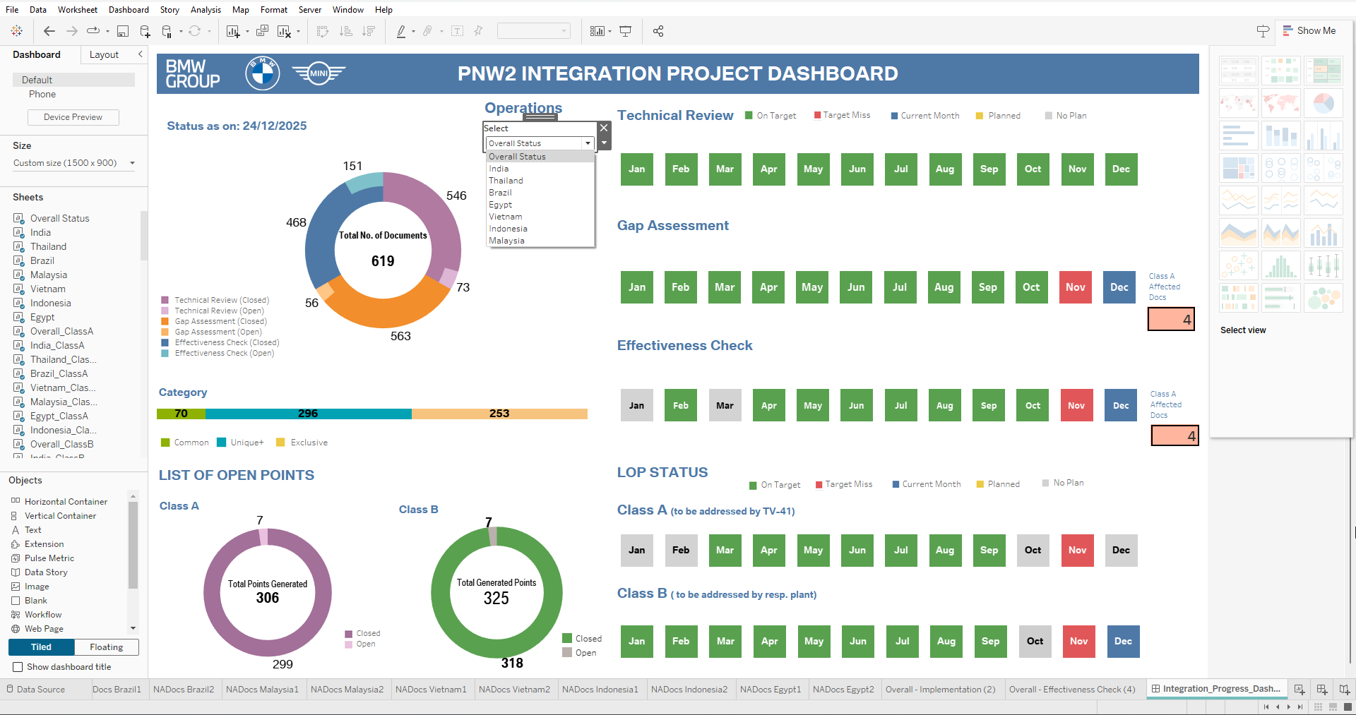

Additionally, I contributed to enhancing the dashboards by integrating sustainability-related information, which aligned with BMW’s global sustainability initiatives. This made the dashboards more meaningful and future-focused.
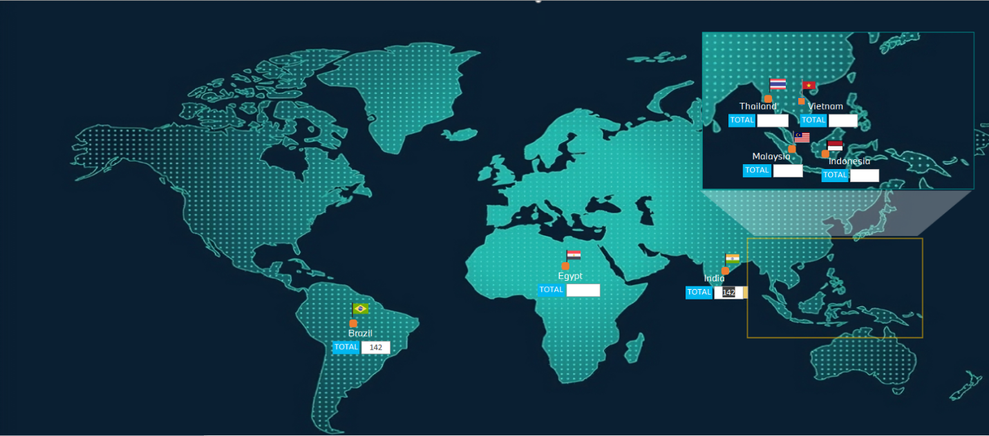
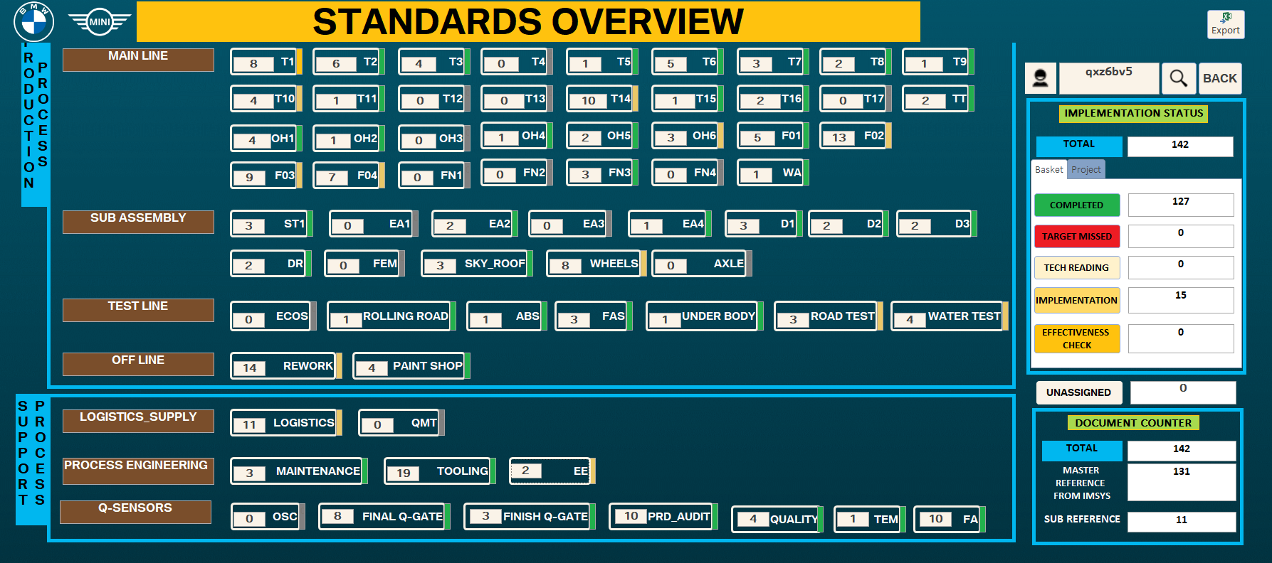

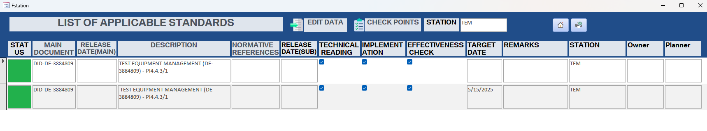
6.2 Database Connectivity & ETL Workflow
To ensure correct and structured data, I worked with:
- Panama Database
- Power Query
- Excel-based transformation logic
Responsibilities Included
- Connecting datasets correctly
- Cleaning unwanted or duplicate values
- Structuring data for easier interpretation
- Ensuring consistency across multiple country datasets
- This strengthened my understanding of industrial ETL workflows and real-world data handling.

6.3 Development of Gantt Chart and Planned Leave Form
One of my initial major contributions was creating a Gantt Chart to visually monitor Functional Analysis activities.
Highlights
- Designed clearly structured timeline layout
- Ensured clarity in process tracking
- Immediately recognized and implemented
- Printed, laminated, and displayed in department
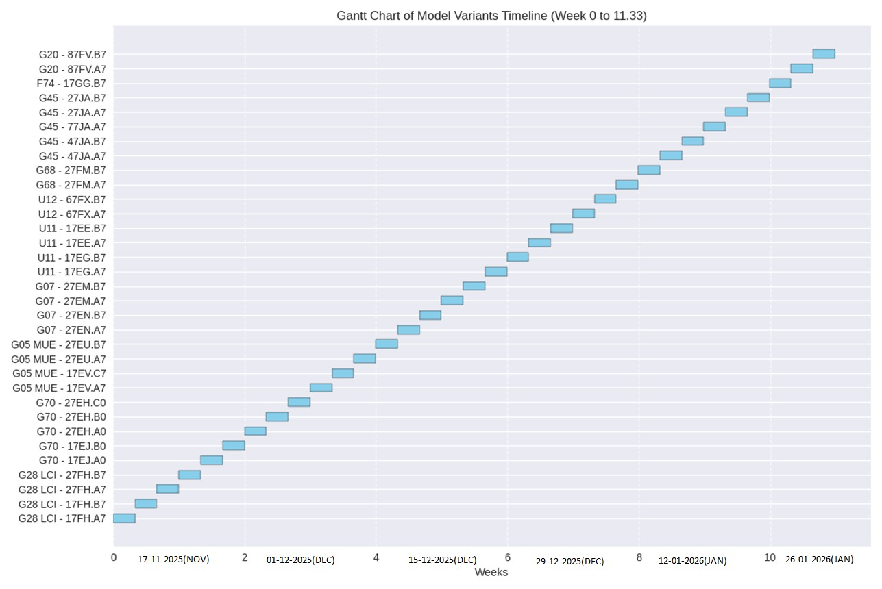Seeing this immediately used in production was a proud moment and a motivating milestone for me.

Planned Leave / Permission Form Creation
- Designed a form for the Functional Analysis for easy marking of Planned Leave and Permissions

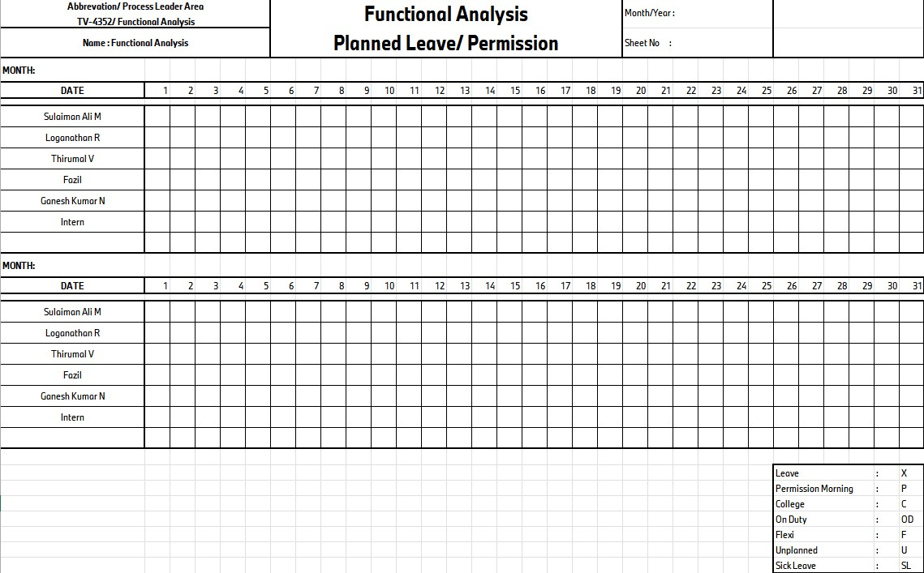

6.4 Major Case Study – Automation Using Power Query
This was one of the most impactful contributions during my internship.

Problem
Two datasets had duplicate keys and mismatched values. Manual reconciliation:
- Took almost 8 hours
- Was tiring and error-prone
- Lacked audit traceability

Solution Implemented
I automated the process using Power Query.
Steps Performed
- Imported both datasets
- Performed Left Outer Join
- Extracted required values
- Automated duplication control
- Generated aligned output

Impact
- Processing time reduced from 8 hours to 10 minutes
- About 98% time savings
- Removed human error risks
- Created a reusable scalable solution
This automation became a strong reference for future similar reconciliation activities and contributed significantly to process efficiency.

6.5 Facility Department Tableau Dashboards
I was assigned to develop Tableau dashboards for the Facility Department. I took this as a challenge and delivered:
- Two fully functional dashboards
- Completed within a day
- Coordinated with the Facility Department
- Ensured production readiness

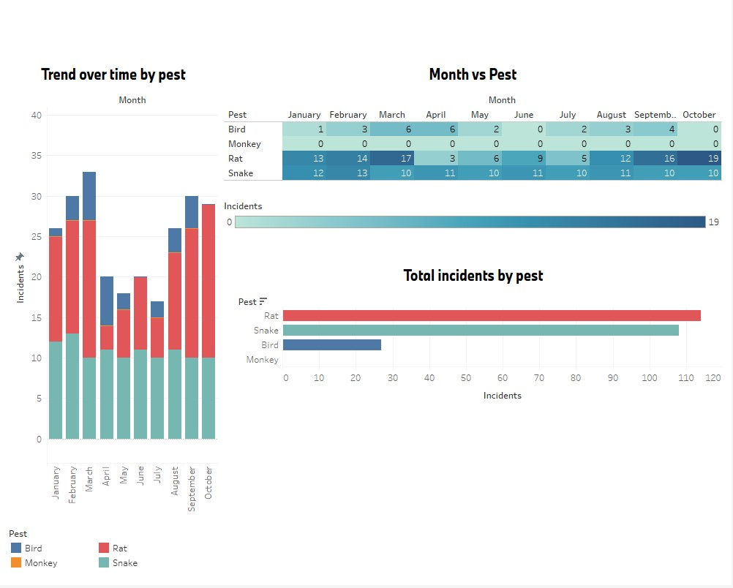

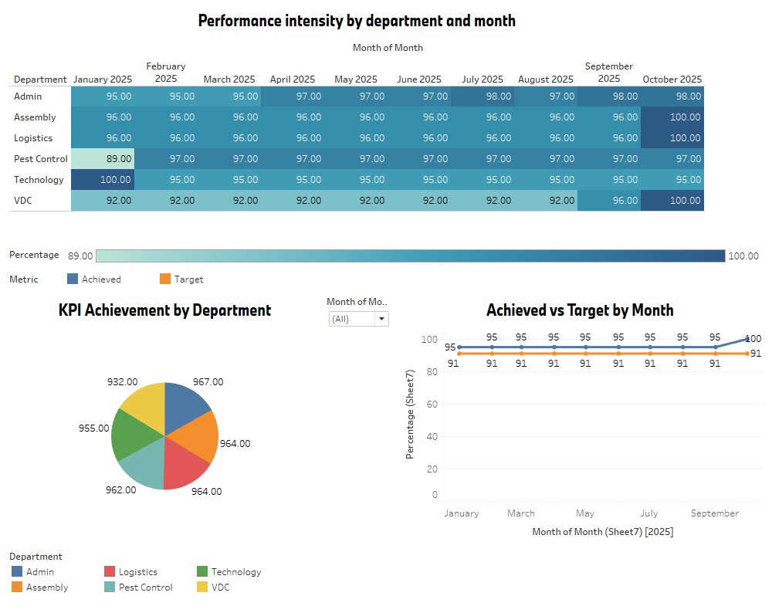
This experience taught me speed with responsibility, structured thinking, and the ability to convert requirements into working outputs.

6.6 Process Confirmation & Monitoring System
To support monitoring whether processes were followed as expected, I designed a Process Confirmation Sheet.
Features
- Conditional formatting
- Logical validations
- Master data integration
- Dashboard connection in Tableau
This ensured improved visibility and process discipline.
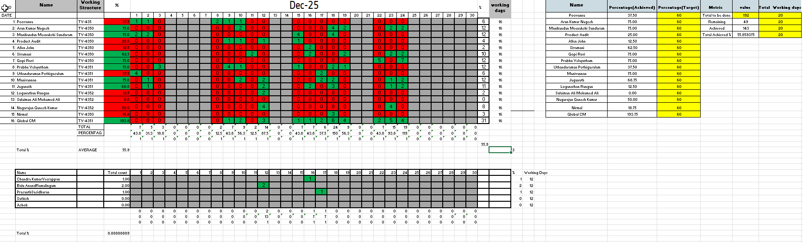
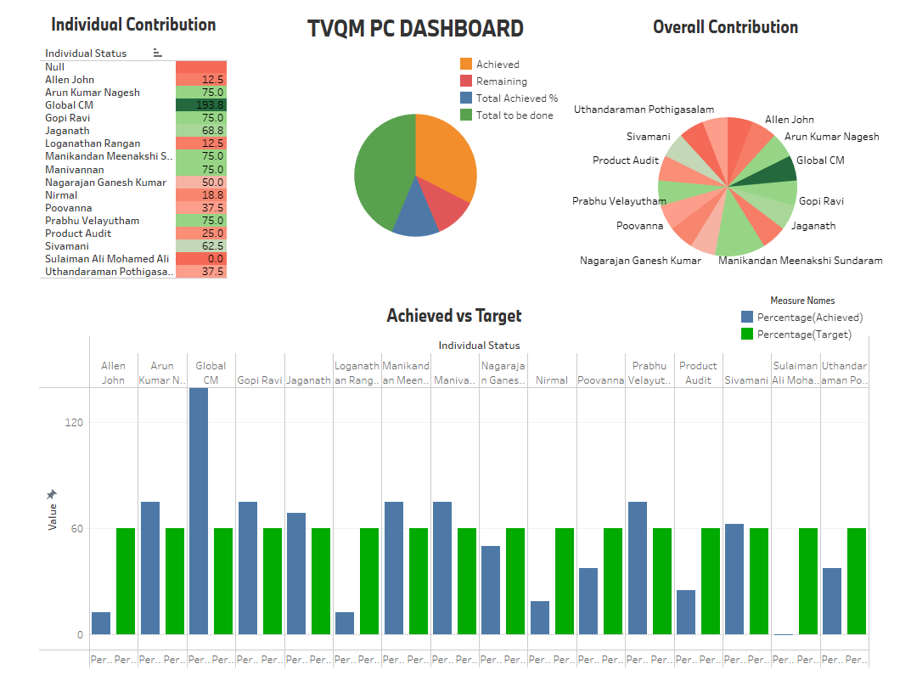

6.7 PSP Team Collaboration & Documentation Governance

Working with the Process Specialist (PSP) team gave me strong exposure to production documentation handling.

Key Tasks
- Validating documents used in assembly
- Updating remark statuses
- Supporting Brazil & Indonesia document updates
- Using Power Query and automation for transformations
- Filtering data to derive meaningful insights
This strengthened compliance visibility and supported production governance.

6.8 Main Functional Project – Master Consolidation System

The major project assigned to me was to design a Master Consolidated Framework that reduced repetitive manual effort and improved clarity.

System Features
- Multi-sheet integration
- Linked using VLOOKUP and XLOOKUP
- Converted values into binary indicators
- Identified delta differences with main database
- Reduced manual monitoring burden
- Enabled structured consolidation

Impact
- Easy understanding of multi-country data
- Reduced recurring workload
- Improved escalation clarity
- Supported better questioning and governance

Regular meetings with country representatives were conducted to align progress, making this system practically useful.

CHAPTER 7
MEETINGS AND GLOBAL COMMUNICATION EXPERIENCE

During my internship at BMW Group Plant Chennai, I had the valuable opportunity to participate in meetings, discussions, and review interactions that helped me understand how professional communication functions in a global organization. These interactions were critical for aligning processes, sharing updates, resolving issues, and ensuring coordinated execution across different countries and departments.

7.1 Internal Department Meetings
- Regular discussions were conducted with the Functional Analysis team to:
- Review dashboard performance
- Monitor documentation progress
- Discuss ETL and automation-related tasks
- Share observations and improvement possibilities
These meetings helped me understand the importance of structured communication, minute detailing, and clarity in presenting data-driven insights.

7.2 International Coordination Meetings
Since my work involved handling dashboards and master documentation for multiple countries such as:
- India
- Thailand
- Malaysia
- Egypt
- Vietnam
- Brazil
- Indonesia
I had the opportunity to be part of global communication forums and alignment discussions where:
- Country representatives presented requirements
- Progress updates were discussed
- Queries were clarified
- Expectations were aligned
This experience helped me understand:
- The importance of cultural professionalism
- The need for clear documentation-based communication
- The precision required when communicating anything related to production or quality

7.3 Presentation Exposure
Whenever required, I explained:
The logic behind automation activities
- The functionality of dashboards
- The importance of documentation governance
- The outcomes of master consolidation systems
This strengthened my confidence in explaining technical work in a clear and simple manner, while maintaining professional tone and clarity.

7.4 Professional Communication Learning
Through these interactions, I learned:
- How structured organizations communicate internally
- How discussions are conducted with clear agenda and outcomes
- How accountability and ownership are upheld
- How politeness, clarity, and accuracy form the foundation of corporate communication

These meetings did not just improve my technical clarity; they shaped my communication maturity and professionalism significantly.

CHAPTER 8
LEARNING OUTCOMES

The internship experience at BMW Chennai was not limited to performing tasks; it was a powerful learning journey that transformed me both technically and professionally. The exposure I gained has permanently enhanced my engineering perspective, quality mindset, and confidence.

8.1 Technical Learning Outcomes
8.1.1 Data Handling & Analytics
I gained strong learning in:
- Managing live analytical dashboards
- Working with real production datasets
- Ensuring accuracy and validation before use
- Understanding the importance of reliable data in decision-making

8.1.2 ETL and Automation
I deeply learned:
- Power Query automation techniques
- Left Outer Join merging logic
- Transformation handling
- Duplicate control
- Excel automation using advanced formulas
This strengthened my capability in industrial ETL thinking.

8.1.3 Dashboard Development
I learned:
- Tableau dashboard structuring
- Integrating datasets
- Designing meaningful visual layouts
- Ensuring dashboards serve practical decision purposes

8.1.4 Documentation Governance
Through PSP collaboration, I learned:
- Importance of documentation accuracy
- Role of compliance in production
- Validation checks and remark recording
- Structured quality record management

8.1.5 Consolidation & Master Governance
From the Master Consolidation System project, I learned:
- Multi-sheet connectivity
- Binary transformation methodology
- Delta comparison logic
- Governance consolidation principles

8.2 Professional Learning Outcomes
8.2.1 Responsibility & Ownership
Handling production-relevant data taught me:
- Accountability
- Accuracy discipline
- Seriousness in execution
8.2.2 Communication & Team Coordination
I improved significantly in:
- Professional communication
- Explaining my work confidently
- Participating in structured meetings
- Collaborating with multi-country teams

8.2.3 Quality & Industrial Culture Understanding
I gained exposure to:
- FMEA
- Six Sigma
- Pareto Analysis
- Fishbone Techniques
These strengthened my quality thinking mindset.

8.2.4 Personal Development
This internship helped me grow with:
- Confidence
- Maturity
- Analytical thinking
- Enthusiasm to contribute more

Overall, this learning experience shaped me both as a student and as a future professional aspiring to contribute meaningfully in the industry.

CHAPTER 9
INDUSTRIAL EXPOSURE AND PRACTICAL LEARNINGS

One of the most enriching parts of this internship was the opportunity to witness and experience real manufacturing processes happening inside BMW Plant Chennai. This helped me connect theoretical knowledge with real-world execution.

9.1 Assembly Line Exposure
I had the privilege of observing:
- Assembly Line 1
- Assembly Line 2
This helped me understand:
- Sequential manufacturing flow
- Coordination between workforce and automation
- The precision and discipline required in automotive production
- How every step contributes to final vehicle quality

9.2 Electric Vehicle (EV) Knowledge
I attended sessions and learning interactions related to:
- Electric Vehicle anatomy
- Functional systems
- Engineering behind BMW EV manufacturing
This gave me insight into how future technology is shaping mobility.

9.3 Simulation & Practical Activities
I witnessed and contributed to:
- A simulation activity involving harness wire placement
This helped me understand:
- Practical difficulties faced in production
- The need for accurate documentation and instructions

9.4 Laser Engraving Process
I observed:
- Laser printing and engraving of vehicles, including limited editions
This showed:
- Precision manufacturing technology
- Brand personalization and specialty work

9.5 Quality Month (November) Participation
I supported:
- Q-Promotion Quality Month Activities
- Engaged actively in department initiatives
- Took responsibility for photography, contributing my hobby meaningfully to the event
This strengthened my bond with the organization culturally as well.
9.6 Safety and Emergency Preparedness
- Participated in a comprehensive fire drill exercise in collaboration with the Tamil Nadu Fire and Rescue Services, gaining practical insights into emergency response procedures and safety protocols.
- Observed and learned how large-scale industrial mock drills are conducted, including practical demonstrations of fire-extinguishing techniques and overall plant safety precautions.
- Gained hands-on experience in following specific plant safety procedures during an emergency simulation, enhancing my understanding of industrial safety management

CHAPTER 10
CONCLUSION

My internship experience at BMW Group Plant Chennai, under the Functional Analysis Department – Total Quality Management, has been truly transformative and deeply inspiring. Over the period from 05 November 2025 to 29 December 2025, I had the honor of contributing to meaningful departmental activities, automation initiatives, documentation governance, dashboard management, and collaborative global processes.
This internship helped me:
- Strengthen my technical foundation in analytics, ETL, automation, and dashboards
- Understand real industrial quality systems and governance
- Develop professional confidence, communication discipline, and accountability
- Experience world-class manufacturing culture and precision-oriented working style

Working in an environment like BMW, which values quality, innovation, structure, and excellence, has motivated me to continuously grow, learn, and aspire to build a strong career in data, quality, and functional analysis domains.

This journey has not only built my technical capability but has shaped me into a more responsible, confident, disciplined, and industry-ready individual. I feel truly proud and grateful to have been a part of BMW Chennai’s quality excellence environment, even as an intern, I will always carry this experience forward as a strong foundation in my professional life.

